Documentation Template

|  |
| --- |
| ***You MUST provide evidence showing how the problem has been decomposed, how the components have been developed and trialed, and of how they have been assembled and tested to create a final, working outcome.*** |

### <https://github.com/Albkset/High-and-low>

### Brief

*Describe your game/quiz.*

<https://trello.com/c/K3jHWEjE/3-%E2%9C%8B%F0%9F%8F%BF-move-anything-that-is-actually-started-here>

I have decided to create a fun game that can be played with friends. I will set up my computer at lunch time and players will play. Here are the rules…

Users will be asked how many will be pat the start of the game. After the players enter number of playing, I will ask for names that will be used in game. The users should press <enter> to play. The computer should then generate a dice. The dice will not be displayed to the player but the number on which the dice lands on will be displayed to the player. The computer will then move the player along the snakes and ladders board till they reach end of a 5 by 5.

The maximum amount of player will be 5. The game will allow player to compete against each other. The players will have a limited number of lives which will be lost if they fall into a black hole or when they land the wrong portal. If the player lands on the right portal they will be teleport up steps. The game will give appropriate feedback so that the users knows where they are the board.

When the players run out of lives they will be removed from the game and by paying an extra 1 dollar they will be added back into the game, but they will start from the first step.

When the players have reached the 25th step. The game will end, and the remaining players will be ranked according to the step they ended on.

Portals is a mimic of an old classic snakes and ladder. Although the core mechanics of the game are the same, I had some changes to them.

Instead of ladders, I am going to use portals to send the player up the board that move the player to set location on the board.

Instead of snakes, I will be using black holes that send the player down the board.

### Outline / Decomposition

*

Modes

Player names

Board and dice

Black holes and portals

### Flowchart

*Please show a developed flowchart of your program below (you may use draw.io to create your flowchart)*

[*https://app.diagrams.net/#HAlbkset%2FHigh-and-low%2Fmain%2Fportalspy%20flowchart.drawio*](https://app.diagrams.net/%23HAlbkset%2FHigh-and-low%2Fmain%2Fportalspy%20flowchart.drawio)*ss*

### Version Log

*Your version log should go here. Annotated screenshots are a good idea at this point*

### Component Testing

*Show that you have tested each component here. You should have a test plan and then screenshot proof for each component. You should also include notes that justify the major decisions you made.*

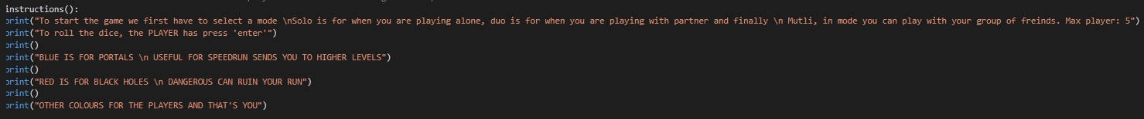

*MODES SELECTION*

*DUO names*

*

**

*The same question is asked but number of times its asked is related to the 0s which are added per player.*

*Basic dice*

*Dice function*

**

*Board component*

*Board works and I can highlight light on the board this is very useful since it can be used to represent portals, black holes and player*

*Win component*

*Checks to see if a player has reached the 100 step if so they win and game ends and if not so they keep going.*

*Win component*

*The win component checks if the player has reached the 100 step or if they are higher than the 100 step if so it sets player turn back to 100 to get this*

*Instead of this*

*Or this*

*If the code only checks if the*

### Assembled Outcome Testing

*Please show testing for your assembled outcome below. This should include a test plan followed by screenshot proof*

*Life system for solo mode works.*

*Main game*

### **Usability Testing (REPEATABLE)**

The color for all players was green and after having multiple tests and feedback telling me that it was hard to tell who was where on the board, I decided to change the player color per player.

I have tested the win component and it works.

Feedback

Geone year 11 🡪 “solo mode is plain and boring, add something that adds a unique taste to it like a life system”

I fixed a problem with solo mode, solo mode was supposed to have a life system, the life system was supposed to make the player lose a life for every time they land on a black hole and when they run out of lives, they lose but due to an error the player was losing a life every time they A picture containing text, monitor, computer, screenshot

press enter

To fix the problem I had to change the code from

To this

To get this

Black hole.

Portals

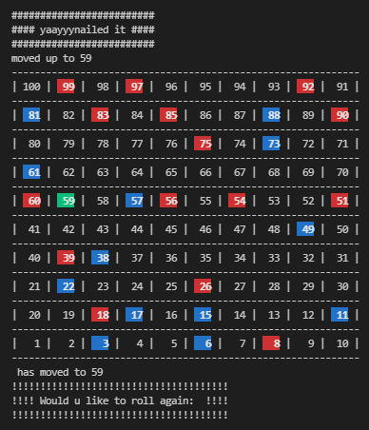

Text changes

FEEDBACK 2

Karl year11 dig 🡪” the player color can’t be the same its hard telling who’s who”

*Write a list of things improvements which need to be made based on your usability testing. Then write down what you changed.*

### **Post Usability Test (REPEATABLE)**

*Show that your post usability testing program works correctly*

FEEDBACK 2

Karl year11 dig 🡪” the player color can’t be the same its hard telling who’s who”

### Social and End User Considerations…

**Who are your target audience / users?**

**Portals has a wide target audience from kids to adults since it is an easy game to play and doesn’t require any special requirements expect luck.**

**Why did you need to ensure that your task was suitable for your chosen audience?**

I need to ensure my game is suitable for all audience since If I don’t, I may create negativity towards snakes and ladders my base game and its community

**How did you ensure that your task was suitable for your chosen audience?**

*I ensured that the game is suitable for all ages by using easy to understand instructions and by making the UI easy to use by anyone.*

**Why do we honor copyright?**

Copyright must be honored because it is considered a part of the human right that says that we are allowed to own creations /property.

**How have you honored copyright?**

*Snakes and ladders is an old game that has been around as early as the 2nd century so copyright doesn’t really apply to it but to turn it in an original I changed some of the basic component like adding a life system.*

**Why do you need to make your quiz easy to use?**

*Snakes and ladders is a game that was made to be played by anyone and since I’m also making snakes and ladders variant that can be played by everyone making it easy is my main focus.*

**How did you make your quiz easy to use?**

*I made the game easier by not making the gameplay complex, to achieve this, I made it so that the game doesn’t require much from the player except their name and pressing enter to roll the dice.*

|  |  |
| --- | --- |
| implication | Implication on the program |

|  |  |
| --- | --- |
| Usability |  |
| Usability is how easily it is for a user to accomplish task and providing the correct instructions and errors. |  |

|  |  |
| --- | --- |
| Functionality |  |
| Functionality is when you ensure that the program works for expected and unexpected cases. |  |
| social |  |
| Social is how the outcome affects the user… for example gambling games can have a negative effect on the user if there is no limit | I have removed the money system and I made sure to use appropriate language |
| Aesthetics |  |
| Aesthetic having a pleasant looking outcome. For example, having a decoration on my responses. |  |